*PLEASE READ ALL INFORMATION IN THIS EMAIL BEFORE TAKING ACTION*
- In your web browser, navigate to www.indianalittleleague.com
- Once you are on the homepage of the website, click on Register in the top right hand corner of the site. This is the first step in the process of CREATING YOUR ACCOUNT.
- If you this is your first time on the website, fill out the Create New Account section on the Login screen. Then click on Create Account.
If you have previously created an account and registered on this specific website, then log in under the “Sign in Here” link.
NOTE: If you are already an account holder, or after creating your account end up back on the league home page, you can click the “MY ACCOUNT” button in the upper right of your screen, and once you are taken to the MY ACCOUNT screen, select “REGISTER NOW” in the upper right part of your screen. You will then be prompted for the following steps to register your participants.

- Fill out the Primary Parent/Guardian Information section. If you wish to add a Secondary Parent/Guardian’s email (e.g. your Spouse) to be cc’d on all Program related emails, enter their information in the Secondary Parent/Guardian Information section and click “Create Secondary Account User & Continue”. If not, leave the area blank and click Submit.

Please Note that a Parent/Guardian only needs to create one (1) User Account to Register as he/she can Register a single child or multiple children and/or Volunteer with that account.

- Select the description that best describes you from this menu:
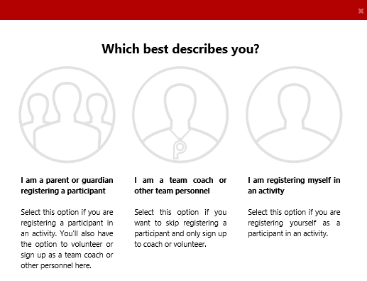

-Anyone registering a child will choose: “I am a parent or guardian registering a participant”
(You will still be able to register yourself as a volunteer during the process)

-Anyone who will be strictly volunteering, with no children registering in the athletic divisions: will choose “I am a team coach or other personnel”

-Any child with parent permission who registers themselves with an account on this site, and signs up for their own division will choose: “I am registering myself in an activity”
- Fill out the Add a New Participant section. Make sure your son or daughter's birth date is set correctly or it might not fall within the division parameters the league has set. Click on Continue. If you have a file of your child’s birth certificate on your computer, you have the option to upload it here. If you do not, you will need to make arrangements to get a copy to league officials. This is the second step in the process of REGISTERING PARTICIPANTS.
NOTE: It is during this step that you will encounter questions in the format pictured below. While confusing, these example show the proper selection for both YES, and NO.
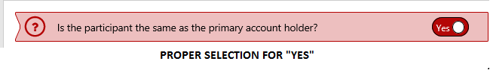
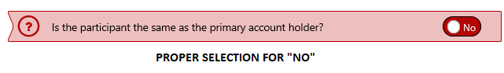
- At this point, you can add all necessary participants that you would like to register.
- Click the “Register” button to the right of the program that you would like to register each participant in. Once the “Register” button turns to green and changes to “Selected”, hit “Continue” in the bottom right.
- Fill in all necessary program information for all participants if it has not already been filled in for you. Hit “Continue”
- Choose all Volunteer roles that apply to you. Keep in mind that these are broken down by division, so pay attention to what division you are choosing the volunteer role for. When selected, the button to the right of the role will change from “Sign Up” to “Selected”. After all roles are selected, hit “Continue”.
- Choose if you would like to select yourself for this role, or invite new account user.
- After selection is made, fill out necessary information for each role selected.
- Review you registration selections in your shopping cart. Once verified, select “Continue”..
- Choose donation amount, or select “I do not wish to contribute at this time”. Select “Continue”.
- You are now at the payment Information screen. Here you may enter your credit card information, or to the right of Payment Method, click on the word Check, and pay at a later date. (ALL MONEY DUE TO LEAGUE BY 3/1/2019).
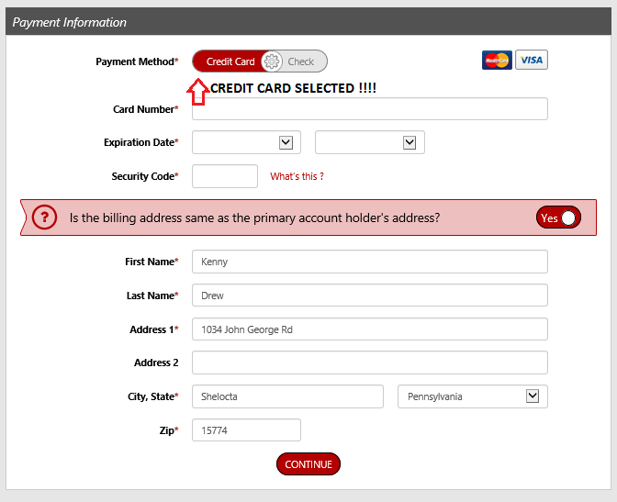
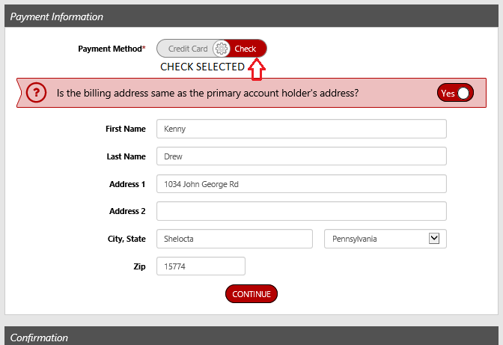

- Verify your registration breakdown by participant, and then hit “Submit Order”.
- Select “Complete Order” on the pop up screen.
You will now see your order detail, and receive an email confirmation.

Your registration is now complete!!!

